**IBM – NALAIYA THIRAN PROJECT**

**INVENTORY MANAGEMENT SYSTEM FOR RETAILERS**

**INDUSTRY MENTOR : KHUSBOO**

**FACULTY MENTOR : KOUSIKA N**

|  |  |  |
| --- | --- | --- |
| **TEAM ID** | **:** | PNT2022TMID02829 |
| **TEAM LEAD** | **:** | SWETHA R S |
| **TEAM MEMBER** | **:** | SHAWPARNIKA M |
| **TEAM MEMBER** | **:** | SREEDEVI V C |
| **TEAM MEMBER** | **:** | VISHALINI C |

**TABLE OF CONTENT**

|  |  |  |
| --- | --- | --- |
| **CHAPTER** | **CONTENTS** | **PAGE NO** |
| **1** | **INTRODUCTION**  1.1 PROJECT OVERVIEW  1.2 PURPOSE | **04** |
| **2** | **LITERATURE SURVEY**  2.1 EXISTING PROBLEM  2.2 REFERENCES  2.3 PROBLEM STATEMENT DEFINITION | **05** |
| **3** | **IDEATION & PROPOSED SOLUTION**  3.1 EMPATHY MAP CANVAS  3.2 IDEATION & BRAINSTROMING  3.3 PROPOSED SOLUTION  3.4 PROBLEM SOLUTION FIT | **10** |
| **4** | **REQUIREMENT ANALYSIS**  4.1 FUNCTIONAL REQUIREMENT  4.2 NON-FUNCTIONAL REQUIREMENTS | **13** |
| **5** | **PROJECT DESIGN**  5.1 DATA FLOW DIAGRAMS  5.2 SOLUTION & TECHNICAL ARCHITECTURE  5.3 USER STORIES | **16** |
| **6** | **PROJECT PLANNING & SCHEDULING**  6.1 SPRINT PLANNING & ESTIMATION  6.2 SPRINT DELIVERY SCHEDULE  6.3 REPORTS FROM JIRA | **20** |

|  |  |  |
| --- | --- | --- |
| **7** | **CODING & SOLUTIONING**  7.1 FEATURE 1  7.2 FEATURE 2  7.3 DATABASE SCHEMA | **30** |
| **8** | **TESTING**  8.1 TEST CASES  8.2 USER ACCEPTANCE TESTING | **34** |
| **9** | **RESULTS**  9.1 PERFORMANCE METRICS | **38** |
| **10** | **ADVANTAGES & DISADVANTAGES** | **40** |
| **11** | **CONCLUSION** | **43** |
| **12** | **FUTURE SCOPE** | **43** |
| **13** | **APPENDIX**  SOURCE CODE  GITHUB & PROJECT DEMO LINK | **44** |

# INTRODUCTION

## Project Overview

In simple words, personal finance entails all the financial decisions and activities that a Finance app makes your life easier by helping you to manage your finances efficiently. A personal finance app will not only help you with budgeting and accounting but also give you helpful insights about money management.Personal finance applications will ask users to add their expenses and based on their expenses wallet balance will be updated which will be visible to the user.  Also, users can get an analysis of their expenditure in graphical forms. They have an option to set a limit for the amount to be used for that particular month if the limit is exceeded the user will be notified with an email alert.

## 1.2 Purpose

Personal finance management is an important part of people’s lives. However, everyone does not have the knowledge or time to manage their finances in a proper manner. And, even if a person has time and knowledge, they do not bother with tracking their expenses as they find it tedious and time-consuming. Now, you don’t have to worry about managing your expenses, as you can get access to an expense tracker that will help in the active management of your finances.

This Expense Tracker is a web application that facilitates the users to keep track and manage their personal as well as business expenses. This application helps the users to keep a digital diary. It will keep track of a user's income and expenses on a daily basis. The user will be able to add his/her expenditures instantly and can review them anywhere and anytime with the help of the internet. He/she can easily import transactions from his/her mobile wallets without risking his/her information and efficiently protecting his/her privacy. He can see the accurate duration for how long a particular product is being used by him. The monthly, and year-wise comparison of expenditures will be done by the app which will let the user know the area where he is spending the most. The user will be able to see the detailed analyses with the help of graphical visualizations. This project will provide a lot of benefits to the users with the help of which they will be surely able to keep track of each penny. It is time to stop using paper and excel sheets to keep track of your digital as well as cash payments. Using paper is not easy to manage. It is common to delete files accidentally or misplace files. This expense tracker provides a complete digital solution to this problem. Excel sheets do very little to help in tracking expenses. Furthermore, they don't have the advanced functionality of preparing graphical visuals automatically. Not only it will save the time of the people but also it will assure error-free calculations. The user just has to enter the income and expenditures and everything else will be performed by the system. Keywords: Expense Tracker, budget, planning, savings, graphical visualization of expenditure.

# LITERATURE SURVEY

## 2.1 Existing problem

(Babad and Balachandran, 1993) states that traditional cost accounting systems maintain all overheads in one pool and give equal weight to all activities and costs in it We always have known that “pen is mightier than sword” but that thing doesn’t fit with every specific tasks it varies from need-to-need or tasks-to-tasks these days when the amount data is quite enormous. It becomes way more difficult to handle them off. Soon excel also become a way on maintain a record of expenses and analysis. Though excel was an effective software to handle such stuff but still lacks in many things so some of the researchers even started using excel with certain tools designed by them. A research at university on Tennessee on expense tracker of by (Dan Underwood, 2011): In which using excel accounting team designed a Cost Allocation tool 1 in which a spreadsheet is used to allocate the product category both by site and the cooperation and a Cost allocation tool 2 which is a developed to further integrate and allocate cost to identify which manufacturer is profitable or which is not. This research used excel and designed this CAT tool in which both the spreadsheets are required to use to identify where we could reduce expenses or better managed it.

(Girish Bekaroo, 2007) did a research on intelligent online budget that manages the expenses and used to give the graphical analysis of data.it uses a Rational Unified Method (RUP) which was way more efficient and advantageous in the way it used to promote code reuse and encapsulation.in which CSS and xml technologies has been used. Students of Sikkim Manipal University an income expense for housewives which not just counts the amount but also maintains date and calendar record of the person as well they used the clustering technique to maintain their data storage.

(Stephan snow and Dhayal Vyas, 2015) mentioned in his paper. “Managing finances is a practice carried out daily in homes across the world. Despite this, the practice is not yet a strong focus for HCI work in the home”. Researchers of Nandha and Anna university (2016) created an android version of expense manager in with they used post and remark techniques for underlining the expenses and some of the data mining features for analyzing the market value well.

(R N Rajprabha, 2017) created an android version of family budget manager with later evolved in PDA and tablet features.

(Ravi Sharma, 2017) stated users sometimes feels uncomfortable in sharing their personal information with an app and he suggested security and usability are two major concerns. Even the advanced UI needs to maintain retention. Researchers of Mother Terresa university, Andhra Pradesh (2019) also stated an online income and budget tracker in a website mode but that project used csv mode to store data but that project had a drawback in its existing model as it can’t handle the data efficiently in addition to that it wasn’t user-friendly and an unpopulated data project. All these researches above suggest some of the modern way of dealing with expense tracking. Many of the researches like these actually represents the evolution in ideas with time “evolution is not a necessity it’s more like change in thinking and time” in which we analyze estimate and evaluate the things according to new requirements. But still the kind of technology used in it is kind of projects were used in previous days there are certain android apps as well still they too also have different consequences as well as drawbacks in itself. And I also feel like these should be way easier to handle to a desktop device. As sometimes android apps will provide in accurate results if the information is incorrect and many of the times, we almost got forget to enter details too and most them don’t even provide notification for that as well. Based on the literature review. This study shows the evolution as well as the comparison from selected researches according to the adopted knowledge in it. This paper suggests some effective changes that are still needed and why the transition is necessary.

## 2.2 References

[1]. D. E. Yurochkin, A. A. Horoshiy and S. A. Karpukhin, "Development of an Application for Expense Accounting," 2021 IEEE Conference of Russian Young Researchers in Electrical and Electronic Engineering (ElConRus), 2021, pp. 753-757, doi: 10.1109/ElConRus51938.2021.9396201.

[2]. S. A. Sabab, S. S. Islam, M. J. Rana and M. Hossain, "eExpense: A Smart Approach to Track Everyday Expense," 2018 4th International Conference on Electrical Engineering and Information &Communication Technology (iCEEiCT), 2018, pp. 136-141, doi: 10.1109/CEEICT.2018.8628070.

[3].<https://bootcamp.uxdesign.cc/expense-manager-application-ui-ux-case-study-the-dignitas-a6714900c60f>

[4]. https://cs2103-ay1819s1-t12-1.github.io/main/DeveloperGuide.html

[5].<https://www.linkedin.com/learning/aws-machine-learning-building-an-expense-tracker-using-amazontextract/expense-tracker-architecture>

[6].<https://www.livemint.com/money/personal-finance/keeping-expenses-in-control-is-key-to-financial-planning11652977556281.html>

[7].<https://www.financialexpress.com/money/your-money-three-smart-ways-to-manage-your-expenses/2522506/>

[8] http://expense-manager.com/how-expense software/

[9] https://www.splitwise.com/terms

[10] http://code.google.com/p/socialauthandroid/wiki/Facebook

[11] http://code.google.com/p/socialauth-android

[12] Developer.android.com

[13] http://www.appbrain.com/app/expensemanager/ com.expensemanager

[14] https://www.xpenditure.com/en?

[15] http://expense-manager.com/how-expense software/

[16] Donn Felker, “Android Application Development for Dummies”, published by For Dummies, 2010.

[17]Ed Burnette, “Hello, Android: Introducing Google's Mobile Development Platform”, published by Pragmatic Bookshelf, 2009.

[18]Lee, “Beginning Android Application Development”, Published by WroxPress, 2011.

## 2.3 Problem Statement Definition

At the instant, there is no as such complete solution present easily or we should say free of cost which enables a person to keep a track of its daily expenditure easily.

To do so a person has to keep a log in a diary or in a computer, also all the calculations needs to be done by the user which may sometimes results in errors leading to losses.

Due to lack of a complete tracking system, there is a constant overload to rely on the daily entry of the expenditure and total estimation till the end of the month.

# IDEATION & PROPOSED SOLUTION

## Empathy Map Canvas

An empathy map is a simple, easy-to-digest visual that captures knowledge about a user’s behaviours and attitudes. It is a useful tool to helps teams better understand their users. Creating an effective solution requires understanding the true problem and the person who is experiencing it. The exercise of creating the map helps participants consider things from the user’s perspective along with his or her goals and challenges.

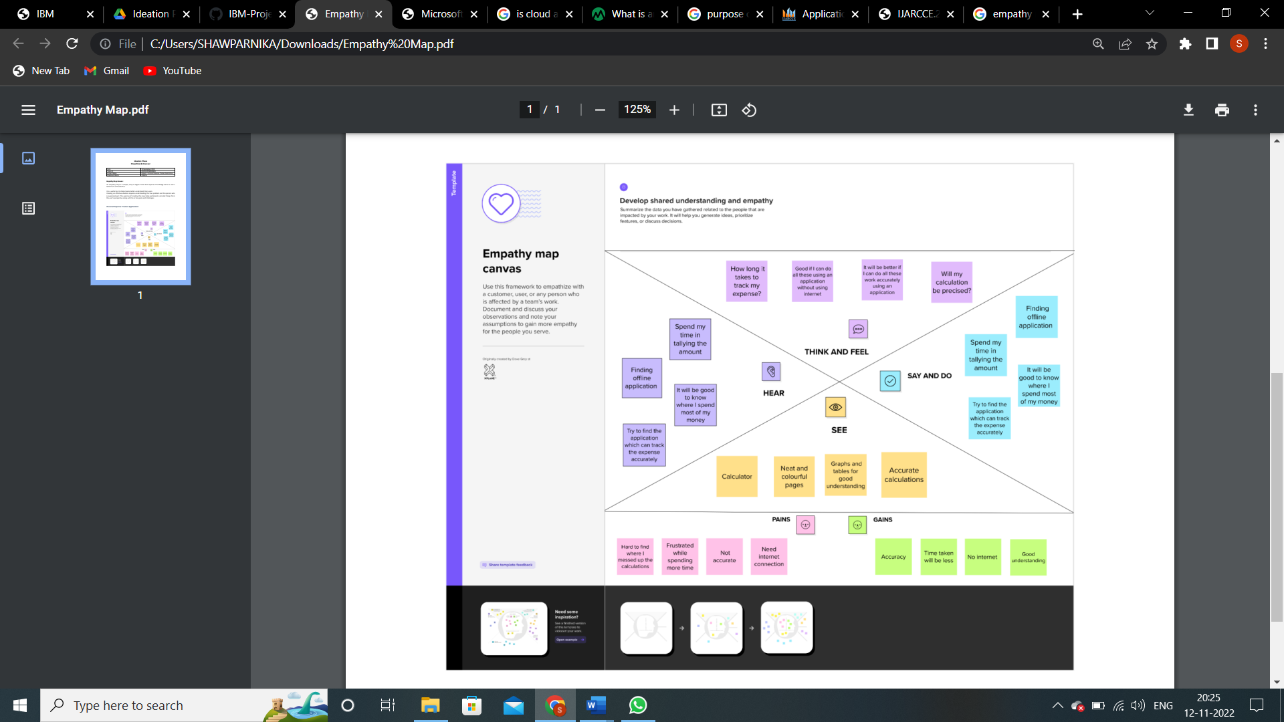

Empathy Map Canvas

## Ideation & Brainstorming

Ideation fundamentally refers to the entire creative process of coming up with and sharing new ideas. Ideation is creative thought that usually aims to solve a problem or offer a better way to do something. It includes coming up with new ideas, developing current ideas, and determining how to put new ideas into effect.

Ideation and brainstorming, a particular method for producing fresh ideas, are frequently closely related activities. When brainstorming, a group of people are usually brought together to generate either new, broad ideas or suggestions for how to handle a particular situation or problem.

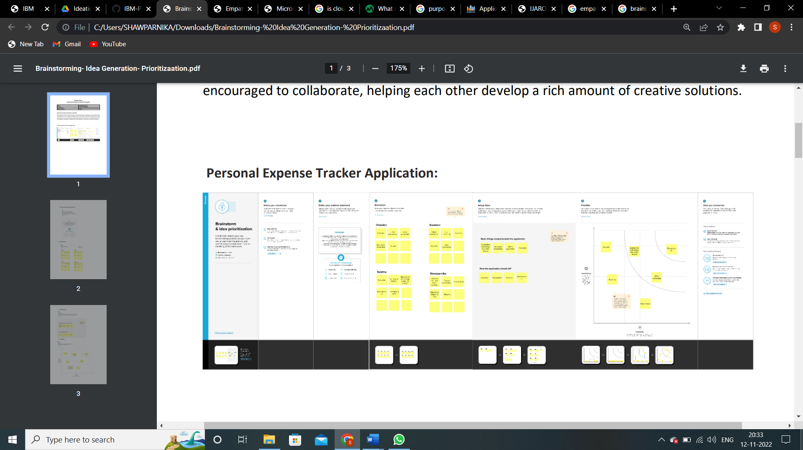

Ideation & Brainstorming

## Proposed Solution

Expense Tracker is going to be an application that It can be accessed any time required.

This application will have a two-tier architecture: first one is the database tier, where all the data and financial data will be stored. Second it will be the user interface which will support the application user communicate with the system and also store Information in the database. The proposed system should operate offline so it can be accessed at any time without internet availability. The proposed system should provide different categories for the user to select from and they can enter the amount and mode of payment.This system should be able to analyze the information,provide analytics on which category did the user spent most of their money.The proposed system should provide a user interface where the user could store and observe their past expenses.

#### 3.4 Problem Solution fit

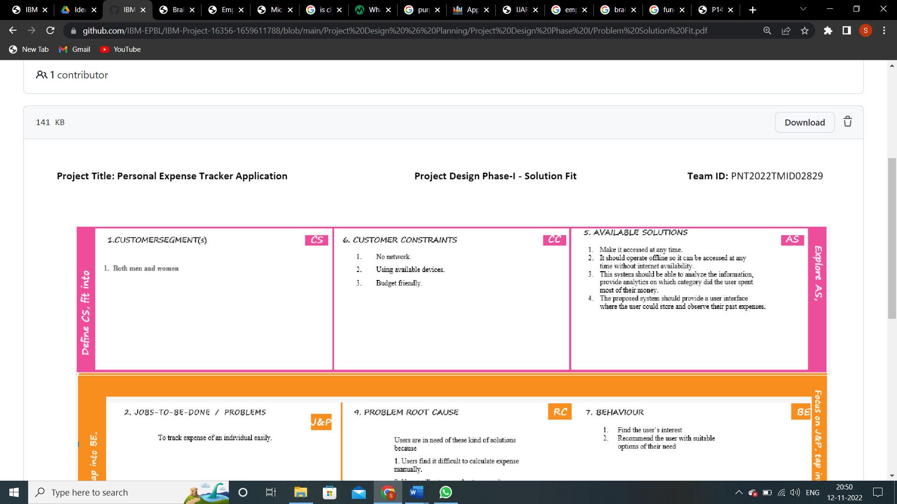

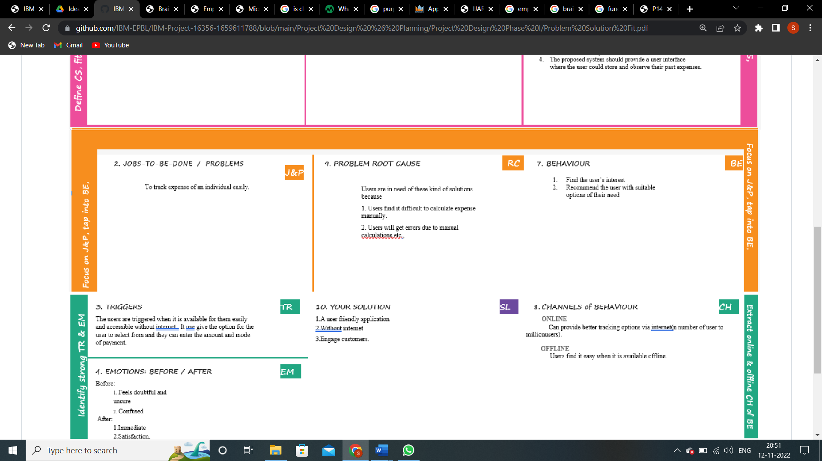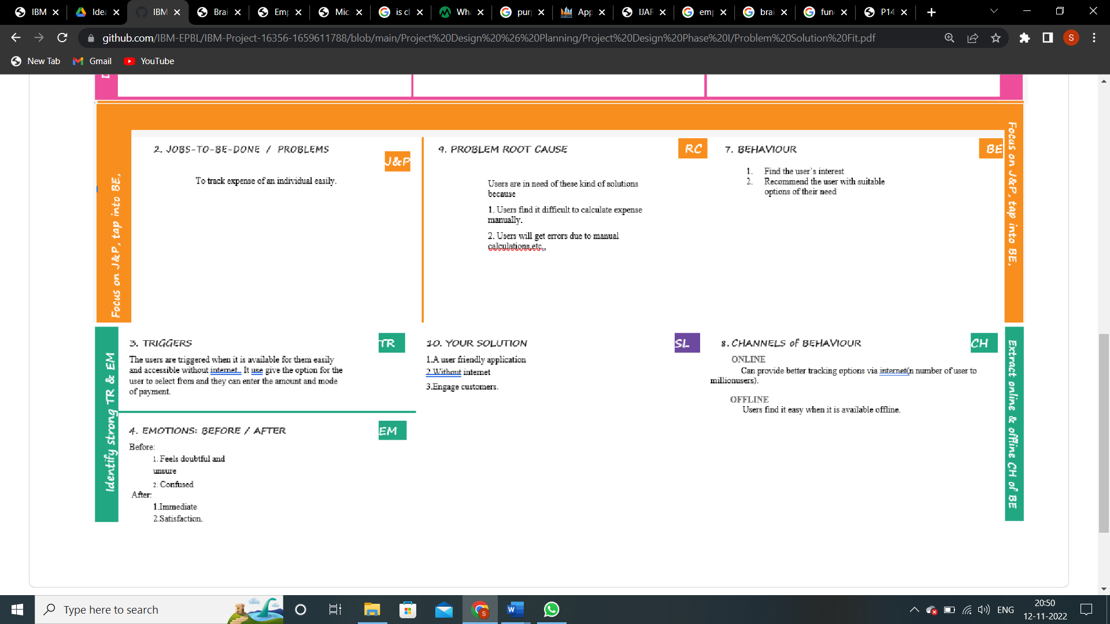

# 4. REQUIREMENT ANALYSIS

## 4.1 Functional requirement

Following are the functional requirements of the proposed solution.

|  |  |  |
| --- | --- | --- |
| **FR No.** | **Functional Requirement (Epic)** | **Sub Requirement (Story / Sub-Task)** |
| FR-1 | User Registration | Registration through Form  Registration through Gmail  Registration through LinkedIN |
| FR-2 | User Confirmation | Confirmation via Email  Confirmation via OTP |
| FR-3 | Login | User can enter the Username and Password to login to the site |
| FR-4 | Display Window | It is split into two screens. The right screen lists the user’s records. The left is the control panel. A user may view his claims. |
| FR-4 | My Status | this displays total expenses for that user. |
| FR-5 | Add Record | It allows user to add new record |
| FR-6 | Delete Record | User can delete the record whenever neccessary |
| FR-7 | Modify Record | it allows the user to edit the details of his records. |

## 4.2 Non-Functional requirements

Following are the non-functional requirements of the proposed solution.

|  |  |  |
| --- | --- | --- |
| **FR No.** | **Non-Functional Requirement** | **Description** |
| NFR-1 | **Usability** | * Creating a learning curve into the site's design and development. * Having a user-friendly, straightforward website. Beautiful-looking website. * Making the website responsive for consumers on both desktops and mobile devices. |
| NFR-2 | **Security** | * Strong security is necessary to prevent hackers from accessing the accounts or data of authorized users. To demonstrate authentication and authorization, log in systems is utilized. * Utilizing OTP can improve security. * Cookies-based security mechanism for user authentication and enhanced website user ✓ experience |
| NFR-3 | **Reliability** | * When the website is active, it should be able to manage the necessary number of users without slowing or causing any inconvenience to the user. * While running the apps, there should be few mistakes. * It should be accessible even during disasters. |
| NFR-4 | **Performance** | * This has the advantage of cutting down the time needed for aisle and product searches, among other conveniences. * It decreases expenses, saves time during restocking, and forecasts the top-selling goods. * Due to the business's streamlined management system, it is more productive ✓ and profitable. |

|  |  |  |  |
| --- | --- | --- | --- |
| NFR-5 | **Availability** | ✓ To provide high availability of database servers and performances, this employs IBM ✓ DB2. | |
| NFR-6 | **Scalability** | | * Due to DB2's excellent scalability, coding can be created and developed quickly, and new features can be added without much difficulty. * High-scalability IBM Container is utilised in the Docker registry. * Any new functionality can be added by reusing the code. |

# 5. PROJECT DESIGN

## 5.1 Data Flow Diagrams

A Data Flow Diagram (DFD) is a traditional visual representation of the information flows within a system. A neat and clear DFD can depict the right amount of the system requirement graphically. It shows how data enters and leaves the system, what changes the information, and where data is stored.

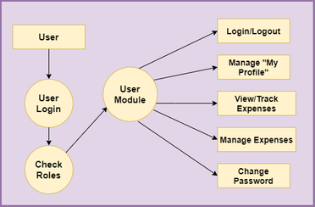

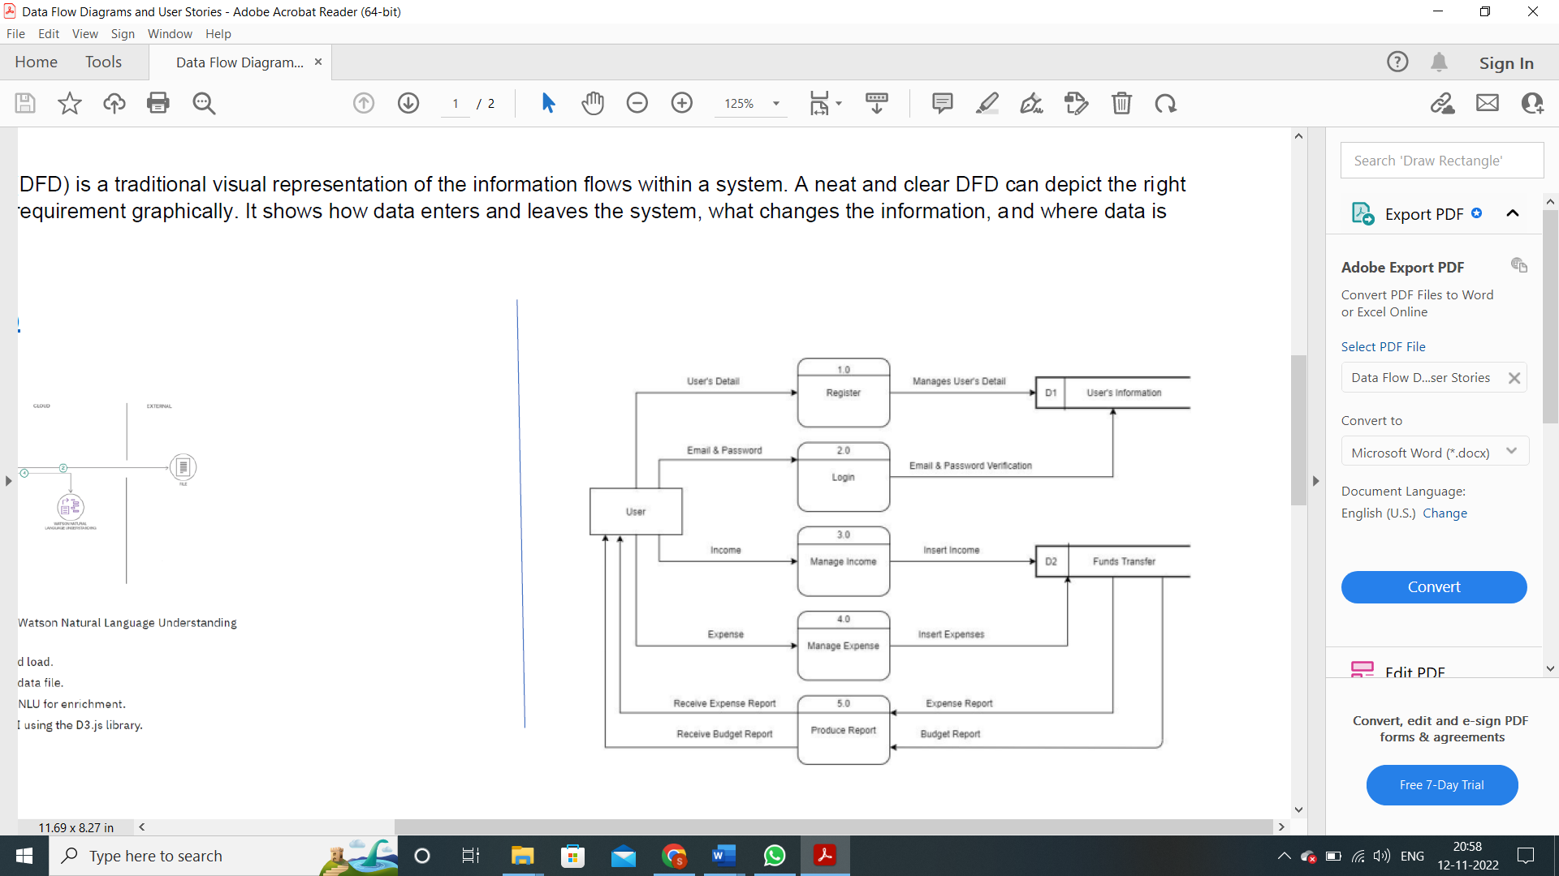

## 5.2 Solution & Technical Architecture

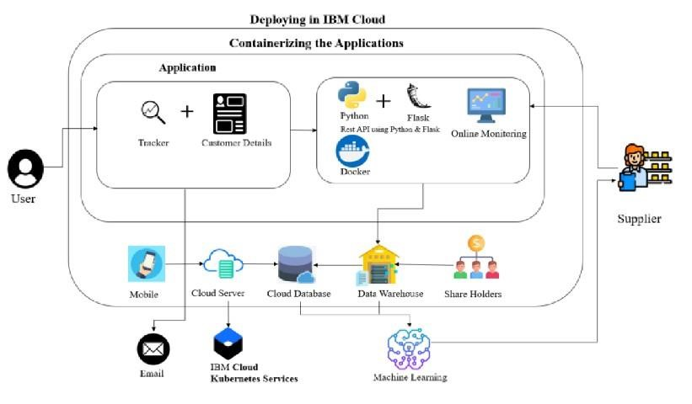

## 5.3 User Stories

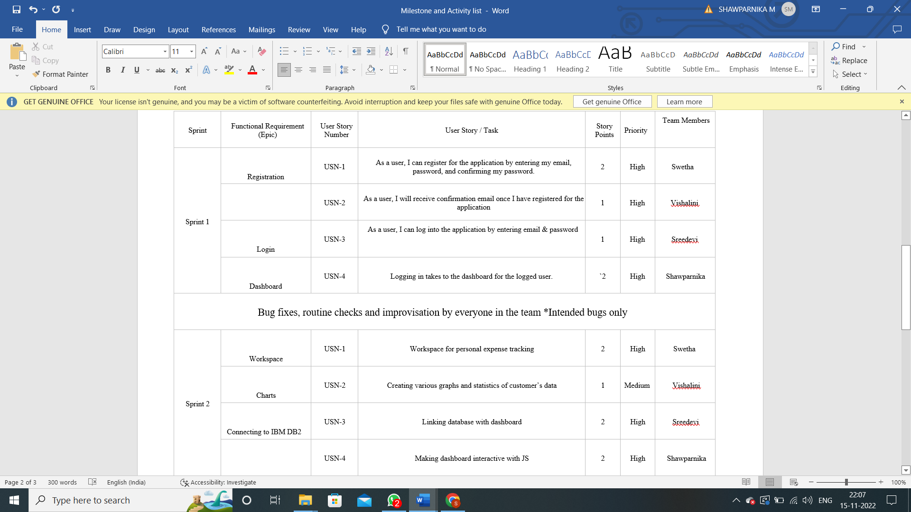

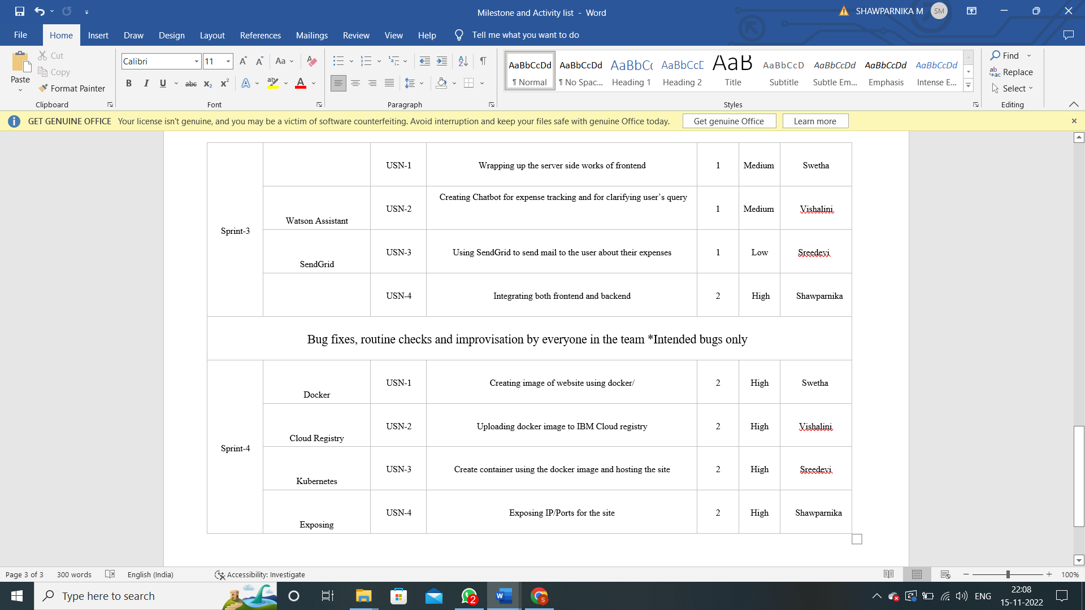

# 6. PROJECT PLANNING & SCHEDULING

## 6.1 Sprint Delivery Schedule

A sprint schedule is a document that outlines sprint planning from end to end. It’s one of the first steps in the agile sprint planning process—and something that requires adequate research, planning, and communication.The product owner typically determines the duration of the sprint and checks with the team to make sure it aligns with its workloads and resources. Sprint planning and scheduling revolves around a product backlog, which is a list of available requests for iteration and development.A product backlog typically contains a variety of requests or user stories from stakeholders like customers, partners, and team members.During sprint scheduling, the product owner and agile development team analyze the product backlog and determine the number of requests they can deliver.Product backlogs continuously evolve as stakeholders generate new requests. That being the case, it’s critical to keep a close watch on the backlog to avoid letting it get too large and unmanageable.Since sprint schedules outline the basic elements of a sprint, there are some universal elements that you should always include.

Start and End Dates : In order to meet your deadlines, you have to provide specific start and end dates for projects and individual sprints. In general, it’s a good idea to communicate with your team before sprint planning to make sure the dates are viable.

Sprint Goals: Every software project and sprint needs clear and concise goals to be effective. There are typically large-scale sprint goals, which may include tasks like building a website or mobile application. For such projects, there is usually one large goal and several underlying sprints with individual goals. If a project involves creating a website, a sprint goal might be to build a secure login system or payment portal.

Stories : Within each backlog is a list of individual requests or user stories. For example, you may have requests for items like website buttons and user authentication features. Most product owners go into sprint planning sessions with a list of outstanding user stories and narrow down the list together as a group.

Story Descriptions: The final schedule should contain a list of specific tasks and instructions. The schedule should also clearly assign team members to individual tasks so that everyone is crystal clear about the items they own.

Product managers often ask whether it’s possible to start a sprint without going through the time-consuming scheduling process. If you decide to ditch the sprint scheduling process, do so at your own risk. After all, a lot can go wrong during a sprint and lead to project failure.

Keep Projects on Track: One of the top challenges in software development is keeping projects on schedule. Projects often wind up running past their target launch date, which is frustrating for customers, partners, and internal stakeholders alike. Sticking to a schedule makes it easier to produce software promptly. This also lowers production costs, thereby bolstering the bottom line.

Maximize Efficiency: The act of outlining sprints in a master schedule and planning ahead can help you visualize the process and identify potential challenges and barriers that may arise. Teams often iterate between sprints and make changes as resources and needs change. By taking this approach, teams can maximize efficiency across all touchpoints.

Do Your Due Diligence: In truth, software projects often fail, even when they go according to plan. When this happens, stakeholders usually analyze the process to figure out a determining cause for failure. And for this reason, it’s critical to always have a documentation plan in place that you can cross-reference to make sure you’re on track.

Respect Other People’s Time: Right now, we are going through a period known as the Great Resignation. Workers across all fields, from CEOs to developers, are quitting their jobs and pursuing new journeys. This often stems from burnout or being overworked

### Product Backlog, Sprint Schedule, and Estimation

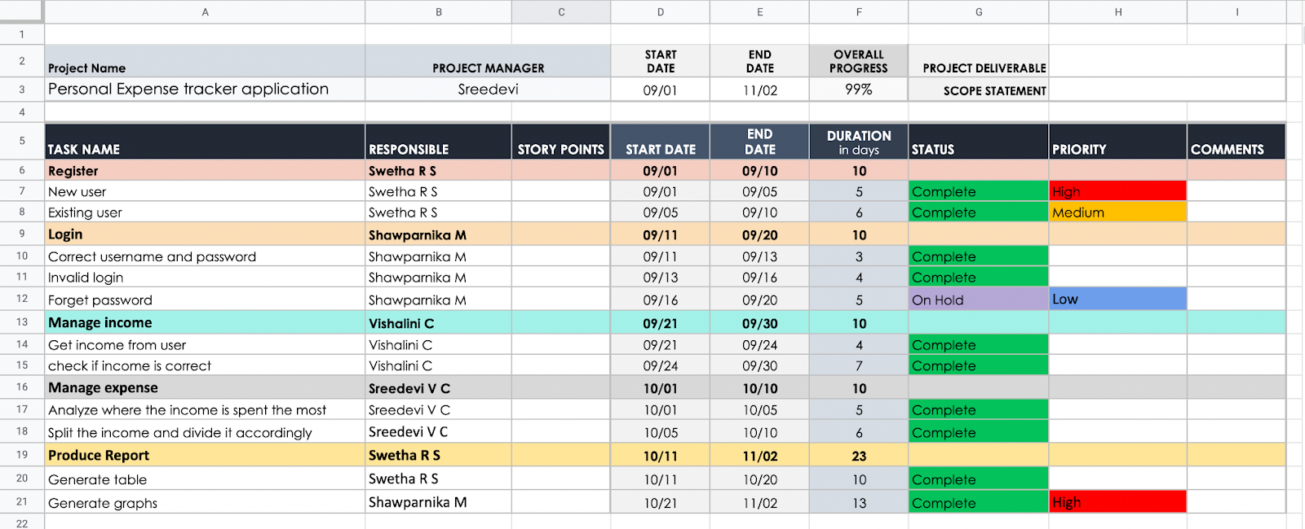

## 6.2 Reports from JIRA

Jira Software enables teams to make data-driven decisions with agile reports, dashboards, and more. Reports in Jira software offer critical insights for scrum, kanban, and any agile methodology in between.Deliver value to customers faster with real-time insights at your fingertips. Jira Software enables teams to make data-driven decisions with agile reports, dashboards, and more.

**Features:**

1.As you plan:

Plan smarter sprints with insights in the backlog.

2.During your sprint:    
Stay on target to meet your goals with insights right in the board view.

3.When you ship

Optimize your delivery pipeline with deployment frequency and cycle time insights.

**Improve delivery and performance with agile reports:**

Reports in Jira software offer critical insights for scrum, kanban, and any agile methodology in between, Reports for scrum teams.

Stay on track of sprint goals and improve retrospectives with data scrum teams can put to use sprint over sprint.

1.Sprint report

Determine overcommittment and excessive scope creep and understand completed work in each sprint.

2.Burndown chart

Track progress towards sprint goals to manage progress and respond accordingly.

3.Release burndown

Track and monitor the projected release date for versions and take action if work is falling behind projected schedule.

4.Velocity chart

Track work from sprint to sprint to helps teams determine the velocity and better estimate the work a team realistically achieve in future sprints.

**Optimize kanban flow for continuous delivery**

Better predict future performance and spot bottlenecks with agile reports for kanban teams.

1.Cumulative flow diagram

Easily spot blockages by seeing the number of issues that increase in any given state.

2.Control chart

Determine future performance with cycle and lead times for your product, version, or sprint.

**Project Tracker, Velocity:**

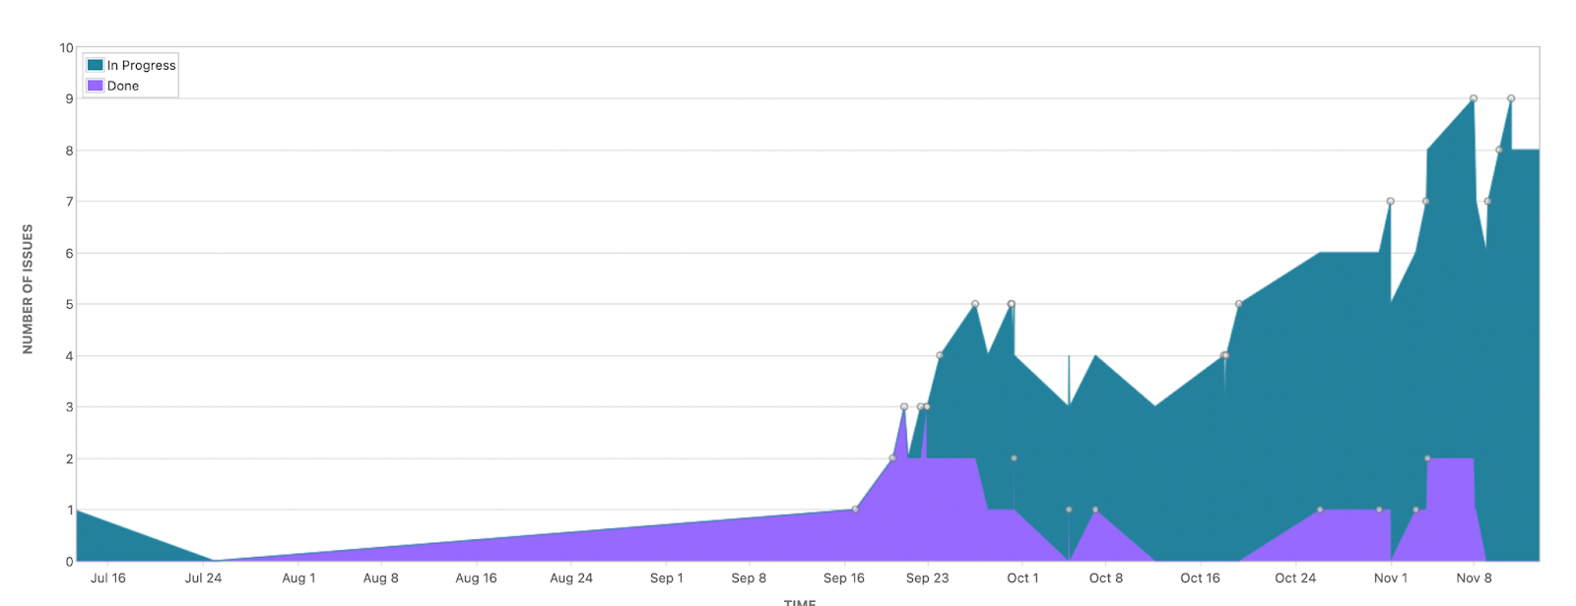

**Velocity:**

Imagine we have a 10-day sprint duration, and the velocity of the team is 20 (points per sprint). Let’s calculate the team’s average velocity (AV) per iteration unit (story points per day)



Our velocity should be:

AV =  =  = 1.29

**Burndown Chart:**

A burn down chart is a graphical representation of work left to do versus time. It is often used in agile [software development met](https://www.visual-paradigm.com/scrum/what-is-agile-software-development/)hodologies such as [Scrum.](https://www.visual-paradigm.com/scrum/scrum-in-3-minutes/) However, burn down charts can be applied to any project containing measurable progress over time.

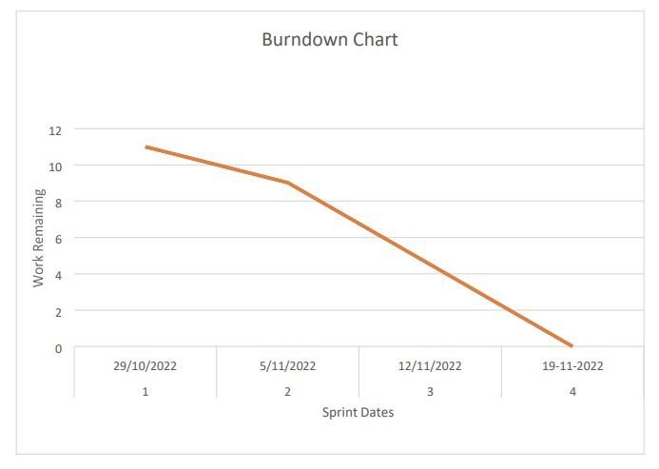

# 7.CODING & SOLUTION

## 7.1 Feature 1

**Dashboard**

<!doctype html>

<html lang="en">

<head>

<!-- Required meta tags -->

<meta charset="utf-8">

<meta name="viewport" content="width=device-width, initial-scale=1">

<!-- Bootstrap CSS -->

<link href="https://cdn.jsdelivr.net/npm/bootstrap@5.0.2/dist/css/bootstrap.min.css" rel="stylesheet" integrity="sha384-EVSTQN3/azprG1Anm3QDgpJLIm9Nao0Yz1ztcQTwFspd3yD65VohhpuuCOmLASjC" crossorigin="anonymous">

<!-- bootstrap for the cards -->

<link rel="stylesheet" href="https://cdn.jsdelivr.net/npm/bootstrap@4.0.0/dist/css/bootstrap.min.css" integrity="sha384-Gn5384xqQ1aoWXA+058RXPxPg6fy4IWvTNh0E263XmFcJlSAwiGgFAW/dAiS6JXm" crossorigin="anonymous">

<title>Dashboard</title>

<link rel="stylesheet" href="https://maxcdn.bootstrapcdn.com/bootstrap/3.3.7/css/bootstrap.min.css" integrity="sha384-BVYiiSIFeK1dGmJRAkycuHAHRg32OmUcww7on3RYdg4Va+PmSTsz/K68vbdEjh4u" crossorigin="anonymous">

<link rel="stylesheet" href="https://maxcdn.bootstrapcdn.com/bootstrap/3.3.7/css/bootstrap-theme.min.css" integrity="sha384-rHyoN1iRsVXV4nD0JutlnGaslCJuC7uwjduW9SVrLvRYooPp2bWYgmgJQIXwl/Sp" crossorigin="anonymous">

<style>

.body{

padding: 50px;

}

.content {

padding: 100px;

}

.color{

color: black;

background-color: white;

}

.weight{

font-weight: bold;

background-color: white;

}

</style>

</head>

<script src="https://cdn.jsdelivr.net/npm/bootstrap@5.0.2/dist/js/bootstrap.bundle.min.js" integrity="sha384-MrcW6ZMFYlzcLA8Nl+NtUVF0sA7MsXsP1UyJoMp4YLEuNSfAP+JcXn/tWtIaxVXM" crossorigin="anonymous"></script>

<div class="container-fluid" >

<div class="row flex-nowrap">

<div class="col-auto col-md-3 col-xl-2 px-sm-2 px-0" style="background-color: #B2D3C2">

<div class="d-flex flex-column align-items-center align-items-sm-start px-3 pt-2 min-vh-100" style="color:black">

<p class="d-flex align-items-center pb-3 mb-md-0 me-md-auto text-white text-decoration-none">

<span class="fs-5 d-none d-sm-inline" style="color:black; font-weight: bold;">Personal Expense Tracker</span>

<img src="bank.png" style="width:50px;height: 50px;">

</p>

<ul class="nav nav-pills flex-column mb-sm-auto mb-0 align-items-center align-items-sm-start" id="menu">

<li class="nav-item mt-2" style="background-color:#00AD83; height: 50px; width: 150px; border-radius: 5px;">

<a href="dashboard" class="nav-link align-middle px-0" style="color:black;">

<span class="ms-1 d-none d-sm-inline">Home</span>

<img src="house-outline.svg" style="width:20px;height:20px;margin-left: 5px;">

</a>

</li>

<li class="nav-item mt-2">

<a href="addexpense" class="nav-link px-0 align-middle" style="color:black;">

<span class="ms-1 d-none d-sm-inline">Add Expense</span>

<img src="pay.png" style="width:20px;height:20px;margin-left: 5px;">

</a>

</li>

<li class="nav-item mt-2">

<a href="modifyexpense" class="nav-link px-0 align-middle" style="color:black;">

<span class="ms-1 d-none d-sm-inline">Modify Expense</span>

<img src="edit_icon.svg" style="width:20px;height:20px;margin-left: 5px;">

</a>

</li>

<li class="nav-item mt-2">

<a href="analysis" class="nav-link px-0 align-middle" style="color:black;">

<span class="ms-1 d-none d-sm-inline">View Analysis</span>

<img src="graph.png" style="width:20px;height:20px;margin-left: 5px;">

</a>

</li>

<li class="nav-item mt-2">

<a href="rewards" class="nav-link px-0 align-middle" style="color:black;">

<span class="ms-1 d-none d-sm-inline">Rewards & Goals</span>

<img src="reward.png" style="width:20px;height:20px;margin-left: 5px;">

</a>

</li>

<li class="nav-item mt-2">

<a href="addcategory" class="nav-link px-0 align-middle" style="color:black;">

<span class="ms-1 d-none d-sm-inline">Create category</span>

<img src="category_add.webp" style="width:20px;height:20px;margin-left: 5px;">

</a>

</li>

</ul>

</div>

</div>

<div class="col py-3" style="background-color:#00AD83">

<h3 style="color:black; text-align: center; margin-left: -300px;">Welcome Back! </h3>

<div class="d-flex justify-content-end">

<h3>Wallet Balance: <span><h5 style="display:inline"><i>Rs.25000</i></h5></span></h3>

<a href="updatebalance"><img src="edit_pencil.png"

style="margin-left:5px; height: 30px; width:30px"></a>

</div>

<h3>Here are your expenses:</h3>

<div class="body">

<table align="center" border="0" cellpadding="2" cellspacing="2" class="table table-striped" class="content">

<tr class="weight">

<td>CATEGORY</td>

<td>EXPENSES</td>

</tr>

<tr>

<td>Food</td>

<td>Rs.5000</td>

</tr>

<tr>

<td>Clothing</td>

<td>Rs.2000</td>

</tr>

<tr>

<td>House Rent</td>

<td>Rs.10000</td>

</tr>

<tr>

<td>Electricity Bill</td>

<td>Rs.2500</td>

</tr>

<tr>

<td>Travel</td>

<td>Rs.3000</td>

</tr>

<tr class="weight">

<td>Total</td>

<td>Rs.22500</td>

</tr>

</table>

</div>

</div>

</div>

</div>

</html>

**7.2.Feature 2**

**Home**

<!DOCTYPE html>

<html lang="en">

<head>

<meta charset="UTF-8">

<meta name="viewport" content="width=device-width, initial-scale=1.0">

<link rel="stylesheet" href="..\static\css\home.css">

<title>My Website</title>

</head>

<body>

<!-- Header -->

<section id="header">

<div class="header container">

<div class="nav-bar">

<div class="brand">

<a href="#hero">

<h1><span>M</span>y <span>B</span>udget</h1>

</a>

</div>

<div class="nav-list">

<div class="hamburger">

<div class="bar"></div>

</div>

<ul>

<li><a href="#hero" data-after="Home">Home</a></li>

<li><a href="#services" data-after="Service">Services</a></li>

<li><a href="#about" data-after="About">About</a></li>

<li><a href="#contact" data-after="Contact">Contact</a></li>

<LI><a href="/signin" data-after="Login">-Login-</a></LI>

</ul>

</div>

</div>

</div>

</section>

<!-- End Header -->

<!-- Hero Section -->

<section id="hero">

<div class="hero container">

<div>

<h1>Hello, <span></span></h1>

<h1>Welcome To <span></span></h1>

<h1>Expense Tracker Web application <span></span></h1>

<a href="/signup" type="button" class="cta">Sign-up</a>

</div>

</div>

</section>

<!-- End Hero Section -->

<!-- Service Section -->

<section id="services">

<div class="services container">

<div class="service-top">

<h1 class="section-title">Serv<span>i</span>ces</h1>

<p>MyBudget provides a many services to the customer and industries. Financial solutions to meet your needs whatever your money goals,there is a MyBudget solution to help you reach them </p>

</div>

<div class="service-bottom">

<div class="service-item">

<div class="icon"><img src="https://img.icons8.com/bubbles/100/000000/services.png" /></div>

<h2>Personal Expenses</h2>

<p>Budgeting is more than paying bills and setting aside savings.it's about creating a money plan for the life you want</p>

</div>

<div class="service-item">

<div class="icon"><img src="https://img.icons8.com/bubbles/100/000000/services.png" /></div>

<h2>Investments</h2>

<p>Follow your investments and bring your portfolio into focus with support for stocks,bonds,CDs,mutual funds and more</p>

</div>

<div class="service-item">

<div class="icon"><img src="https://img.icons8.com/bubbles/100/000000/services.png" /></div>

<h2>Online Banking</h2>

<p>MyBudget application can automatically download transactions and send payments online from many financial institutions</p>

</div>

<div class="service-item">

<div class="icon"><img src="https://img.icons8.com/bubbles/100/000000/services.png" /></div>

<h2>Financial Life</h2>

<p>Get your Complete financial picture at a glance. With MyBudget application you can view your all the financial activities

</p>

</div>

</div>

</div>

</section>

<!-- End Service Section -->

<!-- About Section -->

<section id="about">

<div class="about container">

<div class="col-left">

<div class="about-img">

<img src="..\static\images\img-2.png" alt="img">

<div><h2>Founders, CSE-C Last Benchers </h2></div>

</div>

</div>

<div class="col-right">

<h1 class="section-title">About <span>Us</span></h1>

<h2>Financial Solution</h2>

<p>MyBudget financial solution is one among Leading financial company from many years.MyBudget provides a many services to the customer and industries. Financial solutions to meet your needs whatever your money goals,there is a MyBudget solution to help you reach them.u can Contact our service center for further information and also follow our social media for update on new services </p>

<a href="#footer" class="cta">Follow Us</a>

</div>

</div>

</section>

<!-- End About Section -->

<!-- Contact Section -->

<section id="contact">

<div class="contact container">

<div>

<h1 class="section-title">Contact <span>info</span></h1>

</div>

<div class="contact-items">

<div class="contact-item">

<div class="icon"><img src="https://img.icons8.com/bubbles/100/000000/phone.png" /></div>

<div class="contact-info">

<h1>Phone</h1>

<h2>+1 234 123 1234</h2>

<h2>+1 234 123 1234</h2>

</div>

</div>

<div class="contact-item">

<div class="icon"><img src="https://img.icons8.com/bubbles/100/000000/new-post.png" /></div>

<div class="contact-info">

<h1>Email</h1>

<h2>info@gmail.com</h2>

<h2>abcd@gmail.com</h2>

</div>

</div>

<div class="contact-item">

<div class="icon"><img src="https://img.icons8.com/bubbles/100/000000/map-marker.png" /></div>

<div class="contact-info">

<h1>Address</h1>

<h2>4th main-road,Bengaluru,Karnataka,India</h2>

</div>

</div>

</div>

</div>

</section>

<!-- End Contact Section -->

<!-- Footer -->

<section id="footer">

<div class="footer container">

<div class="brand">

<h1><span>M</span>y <span>B</span>udget</h1>

</div>

<h2>Your Complete Financial Solution</h2>

<div class="social-icon">

<div class="social-item">

<a href="#"><img src="https://img.icons8.com/bubbles/100/000000/facebook-new.png" /></a>

</div>

<div class="social-item">

<a href="#"><img src="https://img.icons8.com/bubbles/100/000000/instagram-new.png" /></a>

</div>

<div class="social-item">

<a href="#"><img src="https://img.icons8.com/bubbles/100/000000/behance.png" /></a>

</div>

</div>

<p>Copyright © 2022 SECE IV-CSE-'C' Last Benchers . All rights reserved</p>

</div>

</section>

<!-- End Footer -->

<script src="..\static\js\home.js"></script>

</body>

</html>

**Add Expense**

<!doctype html>

<html lang="en">

<head>

<!-- Required meta tags -->

<meta charset="utf-8">

<meta name="viewport" content="width=device-width, initial-scale=1">

<!-- Bootstrap CSS -->

<link href="https://cdn.jsdelivr.net/npm/bootstrap@5.0.2/dist/css/bootstrap.min.css" rel="stylesheet" integrity="sha384-EVSTQN3/azprG1Anm3QDgpJLIm9Nao0Yz1ztcQTwFspd3yD65VohhpuuCOmLASjC" crossorigin="anonymous">

<title>Add Expense</title>

</head>

<script src="https://cdn.jsdelivr.net/npm/bootstrap@5.0.2/dist/js/bootstrap.bundle.min.js" integrity="sha384-MrcW6ZMFYlzcLA8Nl+NtUVF0sA7MsXsP1UyJoMp4YLEuNSfAP+JcXn/tWtIaxVXM" crossorigin="anonymous"></script>

<script>

function addGroup(e) {

// e.preventDefault();

group = window.prompt('Enter group name: ')

console.log('PROMPT WINDOW SHOWN'+group);

const formData = new FormData();

formData.append("groupname", group);

const xhttp = new XMLHttpRequest();

xhttp.onload = function() {

if (this.readyState == 4 && this.status == 200) {

var groupid= JSON.parse(this.responseText);

console.log(groupid);

// create option using DOM

const newOption = document.createElement('option');

const optionText = document.createTextNode(groupid['groupname']);

newOption.appendChild(optionText);

newOption.setAttribute('value',groupid['groupID']);

const selectDropdown = document.getElementById('group');

selectDropdown.appendChild(newOption);

console.log('GROUPID :'+ groupid['groupID']);

}

}

xhttp.open("POST", "http://localhost:5000/addgroup");

xhttp.send(formData);

}

</script>

<div class="container-fluid" >

<div class="row flex-nowrap">

<div class="col-auto col-md-3 col-xl-2 px-sm-2 px-0" style="background-color: #B2D3C2">

<div class="d-flex flex-column align-items-center align-items-sm-start px-3 pt-2 min-vh-100" style="color:black">

<p class="d-flex align-items-center pb-3 mb-md-0 me-md-auto text-white text-decoration-none">

<span class="fs-5 d-none d-sm-inline" style="color:black; font-weight: bold;">Personal Expense Tracker</span>

<img src="bank.png" style="width:50px;height: 50px;">

</p>

<ul class="nav nav-pills flex-column mb-sm-auto mb-0 align-items-center align-items-sm-start" id="menu">

<li class="nav-item mt-2">

<a href="dashboard" class="nav-link align-middle px-0" style="color:black;">

<span class="ms-1 d-none d-sm-inline">Home</span><img src="house-outline.svg" style="width:20px;height:20px;margin-left: 5px;">

</a>

</li>

<li class="nav-item mt-2" style="background-color:#00AD83; height: 50px; width: 150px; border-radius: 5px;" >

<a href="addexpense" class="nav-link px-0 align-middle" style="color:black;">

<span class="ms-1 d-none d-sm-inline">Add Expense</span><img src="pay.png" style="width:20px;height:20px;margin-left: 5px;">

</a>

</li>

<li class="nav-item mt-2">

<a href="modifyexpense" class="nav-link px-0 align-middle" style="color:black;">

<span class="ms-1 d-none d-sm-inline">Modify Expense</span><img src="edit_icon.svg" style="width:20px;height:20px;margin-left: 5px;">

</a>

</li>

<li class="nav-item mt-2">

<a href="analysis" class="nav-link px-0 align-middle" style="color:black;">

<span class="ms-1 d-none d-sm-inline">View Analysis</span><img src="graph.png" style="width:20px;height:20px;margin-left: 5px;">

</a>

</li>

<li class="nav-item mt-2">

<a href="rewards" class="nav-link px-0 align-middle" style="color:black;">

<span class="ms-1 d-none d-sm-inline">Rewards & Goals</span><img src="reward.png" style="width:20px;height:20px;margin-left: 5px;">

</a>

</li>

<li class="nav-item mt-2">

<a href="addcategory" class="nav-link px-0 align-middle" style="color:black;">

<span class="ms-1 d-none d-sm-inline">Create category</span><img src="category_add.webp" style="width:20px;height:20px;margin-left: 5px;">

</a>

</li>

</ul>

</div>

</div>

<div class="col py-3" style="background-color:#00AD83">

<h3 style="color:white; text-align: center;">Add expense</h3>

<div class="container mt-3" style="width: 600px;">

<div class="card shadow-lg bg-white rounded">

<form action="/addexpense" method="POST">

<div class="card-header" style="text-align: center;">

<span style="display:inline-flex"><h4>Expense Made</h4><img src="pay.png" style=" margin-left:10px; width:30px; height:30px"></span>

</div>

<div class="card-body">

<div class="mb-3">

<label for="amountspent" class="form-label">Amount Spent: (Rs) </label>

<input type="number" class="form-control" name="amountspent" id="amountspent" placeholder="100.00" required>

</div>

<div class="mb-3">

<label for="expensecategory" class="form-label">Expense Category: </label>

<select name="category" id="category" class="form-control" placeholder="Select a category">

<option value="">Select a category</option>

{% for cat in categories %}

<option value="{{ cat[0] }}">{{ cat[1] }}</option>

{% endfor %}

</select>

</div>

<div class="mb-3">

<label for="date" class="form-label">Date of Expense: </label>

<input type="date" class="form-control" name="date" id="date" required></input>

</div>

<div class="mb-3">

<label for="description" class="form-label">Description of Expense: </label>

<input type="text" class="form-control" name="description" id="description"></input>

</div>

<div class="mb-3">

<label for="group" class="form-label">Group(if needed): </label>

<div title="New group" style="float:right" value="Create group" onclick="addGroup()">ADD GROUP</div><br/>

<select name="group" id="group" class="form-control">

<option value="">Select existing group</option>

{% for group in groups %}

<option value="{{ group[0] }}">{{ group[1] }}</option>

{% endfor %}

</select>

</div>

</div>

<div class="card-footer text-muted" style="text-align:center">

<button type="submit" value="submit" style="background-color:#00AD83; border-color:#00AD83; border-radius:5px;">Submit Expense</button>

</div>

</form>

</div>

</div>

</div>

</div>

</div>

<script>

document.querySelector('#date').valueAsDate = new Date();

</script>

</html>

**7.3 Database scheme**

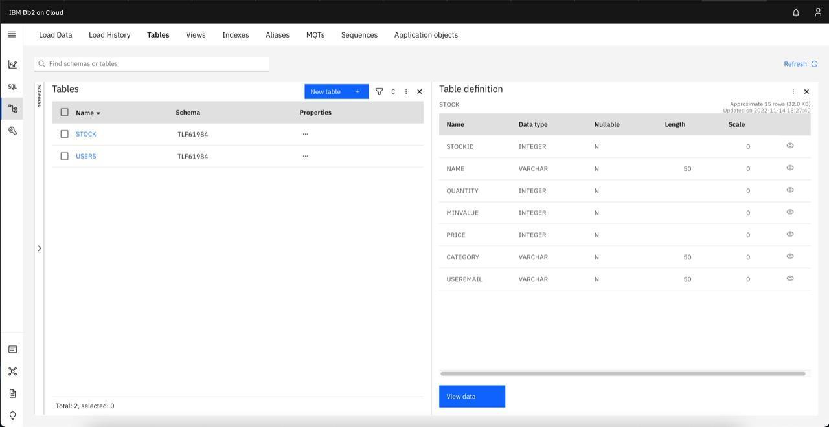

# 8. TESTING

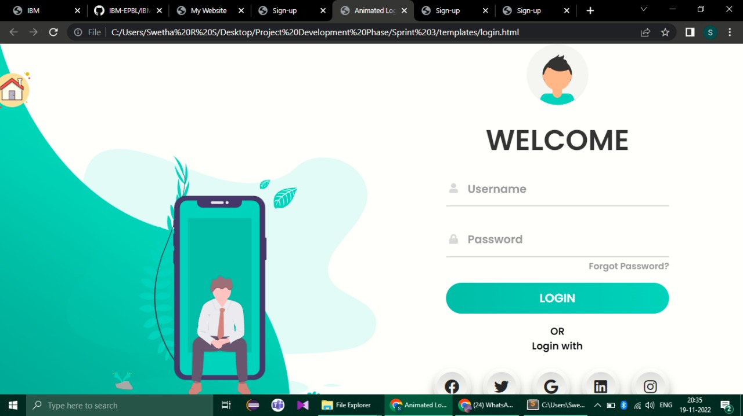

**LOGIN PAGE**

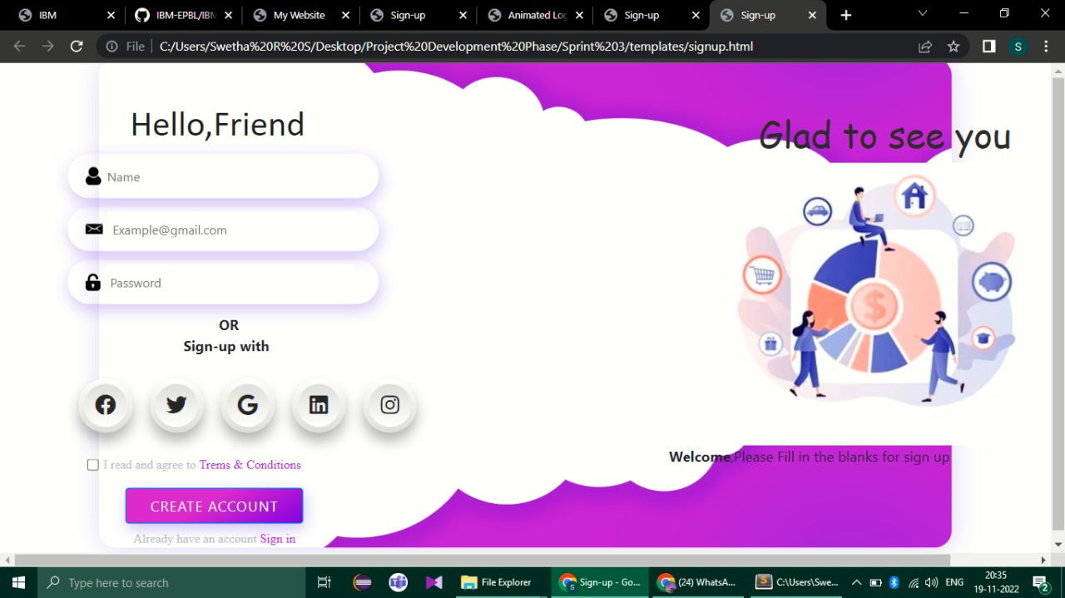

**SIGNUP PAGE**

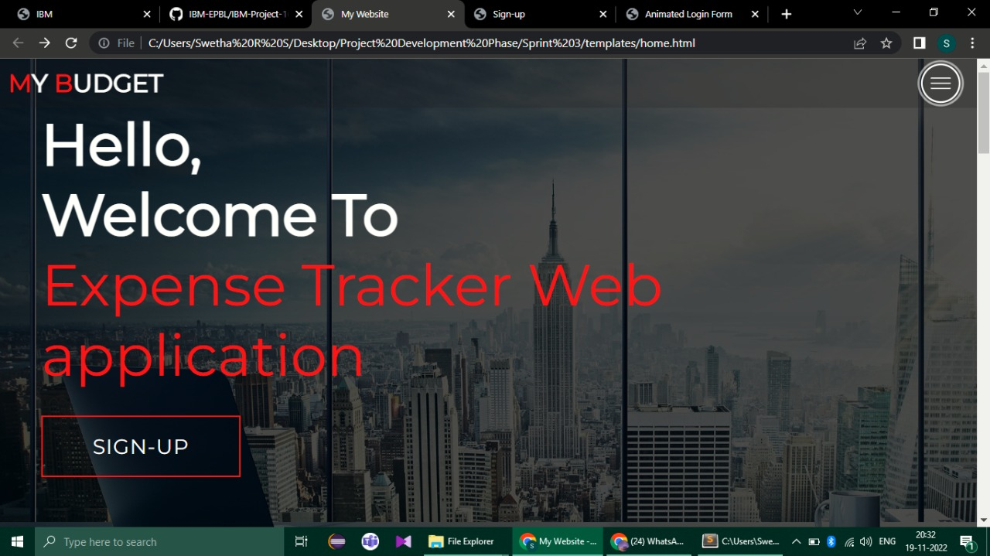

**HOME PAGE**

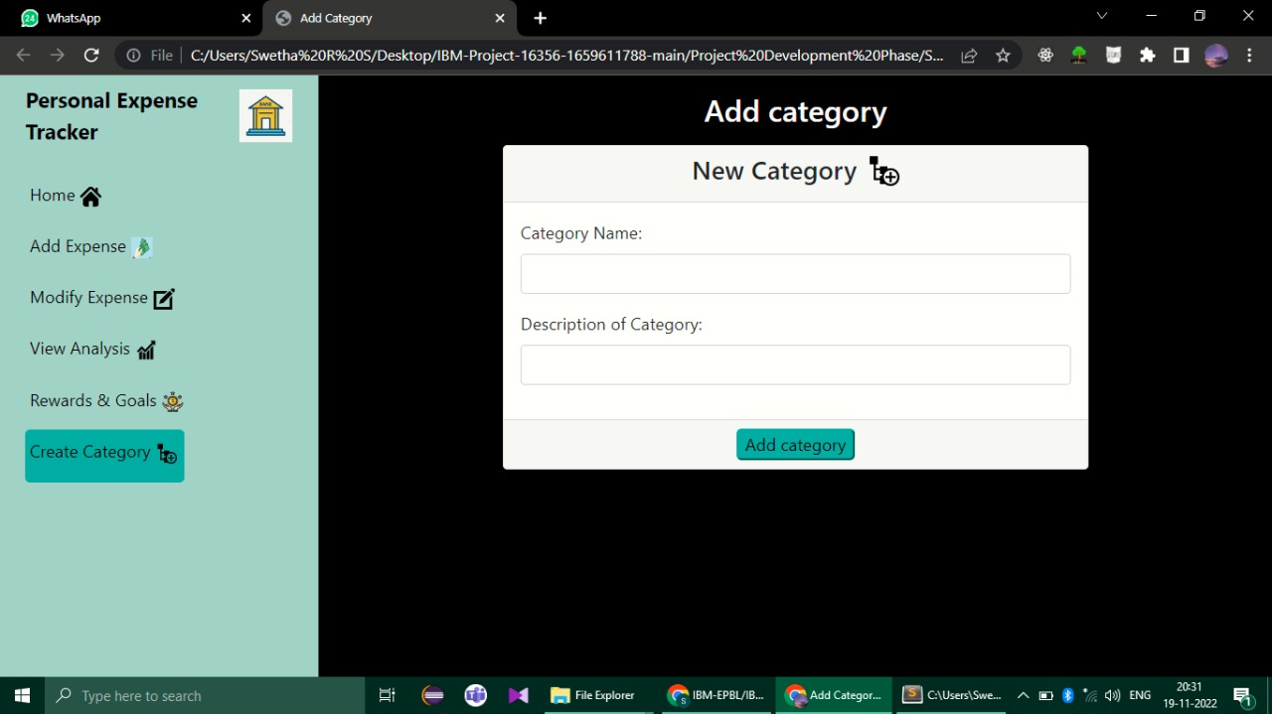

**PRODUCT DISPLAY PAGE**

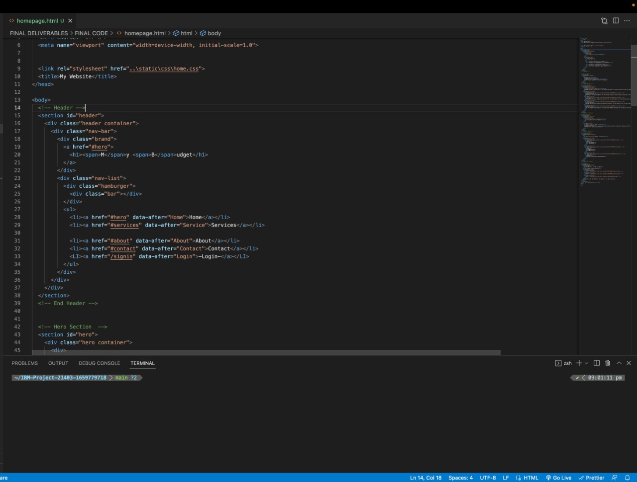

**CODE PAGE**

# 9 RESULTS

## Performance Metrics

1)Accuracy

The accuracy metric is one of the simplest Classification metrics to implement, and it can be determined as the number of correct predictions to the total number of predictions.

2)Confusion Matrix

A confusion matrix is a tabular representation of prediction outcomes of any binary classifier, which is used to describe the performance of the classification model on a set of test data when true values are known. The confusion matrix is simple to implement, but the terminologies used in this matrix might be confusing for beginners.

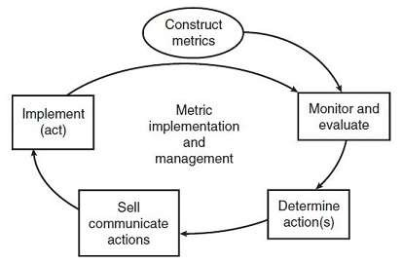

# 10.ADVANTAGES & DISADVANTAGES

## Advantages

**1) You will spend mindfully**

When you write down every expense it helps you spend more mindfully and prevents you from splurging. It makes you responsible with your spending.

**2) Making financial control**

When you track your expenses, you take complete control over your finances. At any one time, you will know exactly how much money is sitting in your bank account, and how much you can spend.

**3) Identify problem areas**

As you track your spending over time, you'll get a better idea of what's happening with your cash. Many of your daily expenses may seem really, but once you add up everything you spend on dining out, coffee, lottery tickets, or whatever your indulgence is, you may be shocked to find out how much your habits actually cost.

**4) Make a better budget**

By tracking your expenses it will help you make clear budgets for your monthly spends. After you set up a budget, which is a monthly plan for spending that takes into account your income and expenses, tracking expenses daily is essential to keeping you on that budget

**5) Tracking your financial progress**

Tracking your expenses on a day-to-day basis helps you to see your progress on the road to your financial goals.

Tracking your expenses on a day-to-day basis helps you to see your progress on the road to your financial goals.

**6) Keeping finances organized**

Disorganized finances lead to financial problems. It is easier to stay organized than it is to organize a messy financial situation.

**7) Improving financial security**

It helps you track your bank accounts. What if somebody steals your debit card information and starts spending your money? If you have a track on your spends you avoid these risks.

**8) Encourages and increases savings**

When you track your expenses you are likely to find wasteful expenses you can eliminate. This will help you encourage and increase your savings. By eliminating wasteful expenses it opens up the opportunity to redirect that money into savings.

**9) Avoids debt**

Tracking your expenses can be a powerful motivator to steer clear of debt. When you are in debt, and not tracking your day-to-day expenses, it’s easy to let the amount of debt you are paying each month slip through the cracks, unnoticed. But, once you start tracking every dollar that leaves your bank account, you will start to add up the debt payments, and it can be eye-opening.

## Disadvantages

1)Your information may be less secure, and probably being used and sold. If the service is free, then the product is you.

2)Mint.com, like other financial apps, is a free service. They have to pay their bills somehow, so regardless of what their privacy policy may or may not say, just assume that your spending history and trends are going to be recorded and analyzed, by someone, somewhere.

3)Now, you shouldn’t have to worry about credit card fraud, these companies are large enough and secure enough that you’ll never have to worry about something like that.

# 11.CONCLUSION

The personal expense tracker application successfully avoids the manual calculation for avoiding calculating the income and expense per month. Monitoring your everyday expenses can set aside you cash, yet it can likewise help you set your monetary objectives for what’s to come. On the off chance that you know precisely where your sum is going much of a stretch see where a few reductions and bargains can be made. Expense Tracker project is for keeping our day-to-day expenditures will helps us to keep record of our money daily. The project what we have created is work more proficient than the other income and expense tracker. The project effectively keeps away from the manual figuring for trying not to ascertain the pay and cost each month. It’s a user-friendly application.

# 12. FUTURE SCOPE

It will have various options to keep record (for example Food, Travelling Fuel, Salary etc). Automatically it will keep on sending notifications for our daily expenditure. In today’s busy and expensive life, we are in a great rush to make money, but at the end of the month we broke off. As we are unknowingly spending money on title and unwanted things. So, we have come over with the plan to follow our profit.

# 13. APPENDIX

# Source code: <https://github.com/IBM-EPBL/IBM-Project-16356-1659611788/tree/main/Project%20Development%20Phase>

### GitHub & Project Demo Link

GitHub Link: <https://github.com/IBM-EPBL/IBM-Project-16356-1659611788/>

Project Demo Link: